COSPAS-SARSAT DEMONSTRATION
AND EVALUATION PLAN FOR
THE 406 MHz MEOSAR SYSTEM

C/S R.018
Issue 2
October 2012

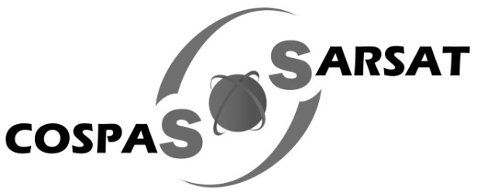

COSPAS-SARSAT DEMONSTRATION AND EVALUATION PLAN
FOR THE 406 MHz MEOSAR SYSTEM

HISTORY

Issue | Revision | Date | Comments
1 | - | October 2011 | Approved by CSC-47
2 | - | October 2012 | Approved by CSC-49
2 | 1 | October 2013 | Approved by CSC-51

TABLE OF CONTENTS
Page

History i
Table of Contents ii
List of Tables iii
List of Figures iv
1. Introduction 1-3
1.1 Management 1-3
1.2 Maintenance of MEOSAR 1-3
1.2.1 SAR/Galileo 1-3
1.2.2 SAR/Galileo 1-3
2. MEOSAR COMPATIBILITY 2-3
2.1 Maintenance of MEOSAR 2-3
2.1.1 SAR/Galileo 2-3
2.1.2 SAR Payload 2-3
2.2 SAR Ground Segment 2-3

LIST OF ANNEXES

ANNEX A A-3
A.1 Paragraphe 1 A-3
A.1.1 Subsection A-3
A.2 Paragraphe 2 A-3
A.3 Paragraphe 2 A-3
ANNEX B B-3
B.1 Section B-3

LIST OF FIGURES

Figure 2.1: Exemple 2-3
Figure 2.2: google logo 2-3
Figure 2.3 : Second Example 2-3

Figure A.1: Test Caption Figure Annex A-3
Figure A.2: Test Caption Figure Annex2 A-3
Figure A.3 fqferfewqr A-3
Figure B.1: Test Caption Figure Annex B B-3

LIST OF TABLES

Table 2.1 : Test Sequence 2-3
Table 2.2 : Test Sequency Number 2-3

Introduction

Management
The Cospas-Sarsat Council (CSC) has directed that a demonstration and evaluation (D&E) be performed to confirm the expected capabilities and benefits of a satellite system in medium-altitude Earth orbit (MEO) that uses onboard repeater instruments to relay distress alert signals emanating from 406 MHz distress radiobeacons.

The Cospas-Sarsat Council (CSC) has directed that a demonstration and evaluation (D&E) be performed to confirm the expected capabilities and benefits of a satellite system in medium-altitude Earth orbit (MEO) that uses onboard repeater instruments to relay distress alert signals emanating from 406 MHz distress radiobeacons. Thi.s system is referred to as the medium-altitude Earth orbiting search and rescue (MEOSAR) system. The CSC further directed that the D&E should establish the technical and operational performance characteristics of the MEOSAR system.
- conducting the D&E of the MEOSAR system in a standard manner among the participants,
- collecting a set of results from individual participants, using compatible formats, that can be consolidated into a final report for review by Cospas-Sarsat participants and other interested parties,
- analysing and translating the results into a set of recommendations for a decision by the Cospas-Sarsat Council.
The Cospas-Sarsat Council (CSC) has directed that a demonstration and evaluation (D&E) be performed to confirm the expected capabilities and benefits of a satellite system in medium-altitude Earth orbit (MEO) that uses onboard repeater instruments to relay distress alert signals emanating from 406 MHz distress radiobeacons. This system is referred to as the medium-altitude Earth orbiting search and rescue (MEOSAR) system. The CSC further directed that the D&E should establish the technical and operational performance characteristics of the MEOSAR system.
- conducting the D&E of the MEOSAR system in a standard manner among the participants; and
- collecting a set of results from individual participants, using compatible formats, that can be consolidated into a final report for review by Cospas-Sarsat participants and other interested parties.
analysing and translating the results into a set of recommendations for a decision by the Cospas-Sarsat Council. analysing and translating the results into a set of recommendations for a decision by the Cospas-Sarsat Council.

Maintenance of MEOSAR

SAR/Galileo
The Cospas-Sarsat Council (CSC) has directed that a demonstration and evaluation (D&E) be performed to confirm the expected capabilities and benefits of a satellite system in medium-altitude Earth orbit (MEO) that uses onboard repeater instruments to relay distress alert signals emanating from 406 MHz distress radiobeacons.

This system is referred to as the medium-altitude Earth orbiting search and rescue (MEOSAR) system. The CSC further directed that the D&E should establish the technical and operational performance characteristics of the MEOSAR system.
- conducting the D&E of the MEOSAR system in a standard manner among the participants; and
conducting the D&E of the MEOSAR system in a standard manner among the participants,
collecting a set of results from individual participants, using compatible formats, that can be consolidated into a final report for review by Cospas-Sarsat participants and other interested parties; and
analysing and translating the results into a set of recommendations for a decision by the Cospas-Sarsat Council.
- collecting a set of results from individual participants, using compatible formats, that can be consolidated into a final report for review by Cospas-Sarsat participants and other interested parties.
conducting the D&E of the MEOSAR system in a standard manner among the participants,
collecting a set of results from individual participants, using compatible formats, that can be consolidated into a final report for review by Cospas-Sarsat participants and other interested parties; and
analysing and translating the results into a set of recommendations for a decision by the Cospas-Sarsat Council.
The Cospas-Sarsat Council (CSC) has directed that a demonstration and evaluation (D&E) be performed to confirm the expected capabilities and benefits of a satellite system in medium-altitude Earth orbit (MEO) that uses onboard repeater instruments to relay distress alert signals emanating from 406 MHz distress radiobeacons. This system is referred to as the medium-altitude Earth.

SAR Payload
The Cospas-Sarsat Council (CSC) has directed that a demonstration and evaluation (D&E) be performed to confirm the expected capabilities and benefits of a satellite system in medium-altitude Earth orbit (MEO) that uses onboard repeater instruments to relay distress alert signals emanating from 406 MHz distress radiobeacons.

SAR Ground Segment
The Cospas-Sarsat Council (CSC) has directed that a demonstration and evaluation (D&E) be performed to confirm the expected capabilities and benefits of a satellite system in medium-altitude Earth orbit (MEO) that uses onboard repeater instruments to relay distress alert signals emanating from 406 MHz distress radiobeacons.

SAR/Galileo
The Cospas-Sarsat Council (CSC) has directed that a demonstration and evaluation (D&E) be performed to confirm the expected capabilities and benefits of a satellite system in medium-altitude

- END OF SECTION 1 -

MEOSAR COMPATIBILITY
The Cospas-Sarsat Council (CSC) has directed that a demonstration and evaluation (D&E) be performed to confirm the expected capabilities and benefits of a satellite system in medium-altitude Earth orbit (MEO) that uses onboard repeater instruments to relay distress alert signals emanating from 406 MHz distress radiobeacons. This system is referred to as the medium-altitude Earth orbiting search and rescue (MEOSAR) system. The CSC further directed that the D&E should establish the technical and operational performance characteristics of the MEOSAR system.

Maintenance of MEOSAR

SAR/Galileo
The Cospas-Sarsat Council (CSC) has directed that a demonstration and evaluation (D&E) be performed to confirm the expected capabilities and benefits of a satellite system in medium-altitude Earth orbit (MEO) that uses onboard repeater instruments to relay distress alert signals emanating from 406 MHz distress radiobeacons. This system is referred to as the medium-altitude Earth orbiting search and rescue (MEOSAR) system. The CSC further directed that the D&E should establish the technical and operational performance characteristics of the MEOSAR system.
- conducting the D&E of the MEOSAR system in a standard manner among the participants;
- collecting a set of results from individual participants, using compatible formats, that can be consolidated into a final report for review by Cospas-Sarsat participants and other interested parties; and
- analysing and translating the results into a set of recommendations for a decision by the Cospas-Sarsat Council.

SAR Payload
The Cospas-Sarsat Council (CSC) has directed that a demonstration and evaluation (D&E) be performed to confirm the expected capabilities and benefits of a satellite system in medium-altitude Earth orbit (MEO) that uses onboard repeater instruments to relay distress alert signals emanating from 406 MHz distress radiobeacons.

SAR Ground Segment
The Cospas-Sarsat Council (CSC) has directed that a demonstration and evaluation (D&E) be performed to confirm the expected capabilities and benefits of a satellite system in medium-altitude Earth orbit (MEO) that uses onboard repeater instruments to relay distress alert signals emanating from 406 MHz distress radiobeacons.

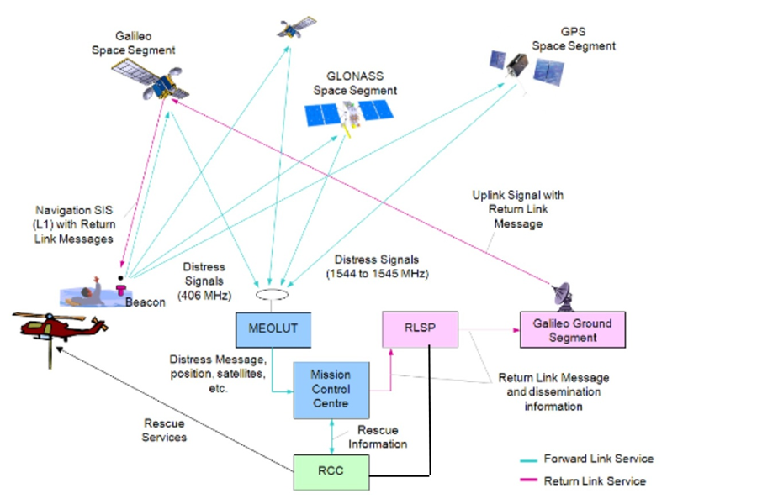
Figure 2.1: Exemple

The Cospas-Sarsat Council (CSC) has directed that a demonstration and evaluation (D&E) be performed to confirm the expected capabilities and benefits of a satellite system in medium-altitude Earth orbit (MEO) that uses onboard repeater instruments to relay distress alert signals emanating from 406 MHz distress radiobeacons.


Figure 2.2: google logo

Figure 2.3 : Second Example

The Cospas-Sarsat Council (CSC) has directed that a demonstration and evaluation (D&E) be performed to confirm the expected capabilities and benefits of a satellite system in medium-altitude Earth orbit (MEO) that uses onboard repeater instruments to relay distress alert signals emanating from 406 MHz distress radiobeacons.

Beacon emission power | Slot No | NTBI  Number transmitted beacon IDs | NVIM  After 7 Bursts. | NCM  After 7 Bursts. | Valid Message Det. Prob. (%) After 7 Bursts.  (NVIM+NCM)/NTBI | Complete Message Det. Prob (%) After 7 Bursts  NCM/NTBI
37 dBm – | Slot 1 | 100
[30 dBm] | Slot 2 | 100
 | ...
37 dBm – | Slot 7 | 100
[30 dBm] | Slot 8 | 100
37 dBm | Slot 95 | 100
[30 dBm] | Slot 96 | 100
Table 2.1 : Test Sequence
Beacon emission power | Slot No | NTBI  Number transmitted beacon IDs | NVIM  After 7 Bursts. | NCM  After 7 Bursts. | Valid Message Det. Prob. (%) After 7 Bursts.  (NVIM+NCM)/NTBI | Complete Message Det. Prob (%) After 7 Bursts  NCM/NTBI
37 dBm – | Slot 1 | 100
[30 dBm] | Slot 2 | 100
 | ...
37 dBm – | Slot 7 | 100
[30 dBm] | Slot 8 | 100
37 dBm | Slot 95 | 100
[30 dBm] | Slot 96 | 100
Table 2.2 : Test Sequency Number

- END OF SECTION 2 -

ANNEX TITLE

Paragraphe 1

Subsection

In the

Figure A.1: Test Caption Figure Annex

Table A.1 : Test Caption Table Annex

Figure A.2: Test Caption Figure Annex2

Figure A.3 fqferfewqr

Paragraphe 2

Paragraphe 2

- END OF ANNEX A -

Section
Figure B.1: Test Caption Figure Annex B

- END OF ANNEX B -

- END OF DOCUMENT -

Cospas-Sarsat Secretariat
1250 Boul. René-Lévesque West, Suite 4215, Montreal (Quebec) H3B 4W8 Canada
Telephone: +1 514 500 7999 / Fax: +1 514 500 7996
Email: mail@cospas-sarsat.int
Website: www.cospas-sarsat.int

blablabla
blablabla
blaablablabla

