MODEL/TEMPLATE LETTER

Advice to SPOCs/RCCs for Use Until Such Time as the LADR Becomes Available
as amended by APSAR/WG/8
ELT(DT) information distribution management

This document provides guidance for the position information distribution management of ELT(DT)s in the absence of the Location of an Aircraft in Distress Repository (LADR), to comply with the ICAO SARPs related to the location of an aircraft in distress through Autonomous Distress Tracking (ADT).

At the time this document was developed, the LADR was under development and not yet ready to accept position information from an ADT device transmitting from an aircraft in distress and notify the appropriate subscribers.

As of 1 January 2023, Cospas-Sarsat declared readiness to operationally process and distribute data from a new beacon type, the ELT(DT). This ELT for Distress Tracking (DT) was specifically developed to support new ICAO Standards as part of its GADSS initiative.

ELT(DT)s are designed to be activated, either automatically or manually, while the aircraft is still in flight. As with all Cospas-Sarsat alerts, ELT(DT) messages shall be distributed directly to SAR authorities by MCCs in accordance with document C/S A.001 section 3.2.3.2.2. An ELT (DT) alert is triggered when an aircraft in-flight enters a state which, if no corrections are made to return that aircraft to a safe flight state, an accident is likely to occur.

An ELT(DT) may be designed using either a First-Generation Beacon (FGB) technology, per document C/S T.001, or as a Second-Generation Beacon (SGB) technology, per document C/S T.018. Currently, all operational beacons are FGBs.

Major aircraft manufacturers have indicated they anticipate delivering aircraft equipped with ELT(DT)s during 2023. The planned ICAO LADR, currently being developed by EUROCONTROL is expected to be available from December 2023. As a result, there will be a number of months during which aircraft will be flying with ELT(DT)s, but the LADR, into which data from ELT(DT)s (and any other ADT devices) is to be submitted for access by air traffic service providers, aircraft operators, rescue coordination centers and other interested parties, will be unavailable.

When the LADR becomes available, Cospas-Sarsat will place data from each ELT(DT) transmission there and continue to alert SPOCs and RCCs directly (as shown in Figure 1).

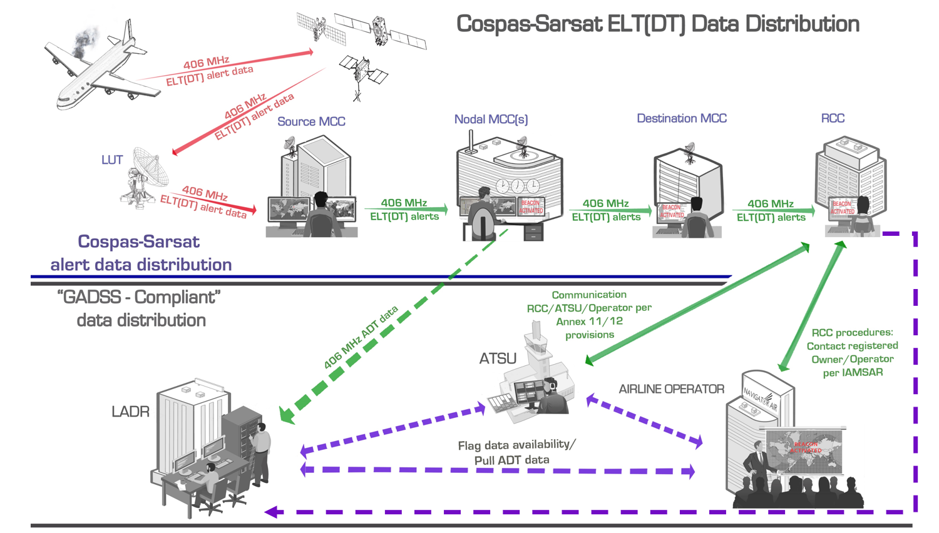

Figure 1: ELT(DT) data will be automatically distributed to designated SAR authorities (i.e., SPOCs), as well as placed in the future in the ICAO LADR, where it will be made available to ATS units, Operators and RCCs that have subscribed to the LADR.

Until the LADR becomes available, search and rescue (SAR) authorities should consider developing procedures with their partner Air Traffic Services Units (ATSUs) to appropriately respond to distress messages emanating from ELT(DT)s from an aircraft still in flight. Such procedures should align with any existing procedures that deal with the coordination of in-flight emergencies between ATSUs and RCCs.

As a basis for further development, proposed SPOC/RCC actions to be taken after receipt of a SIT 185 message from an ELT(DT) could include the following:
- Note that the SIT 185 message reports the detection of a signal from the new beacon type, the ELT(DT); Paragraph 1 of the SIT 185 message contains “DISTRESS TRACKING” and Paragraph 3 clearly identifies the source of the message as “ELT DISTRESS TRACKING”.
- Study the basic event information provided in the ELT(DT) SIT 185 message:
  - Paragraph 3 will provide the State of registration the aircraft decoded from the ICAO 24-bit address, and the operator, both contained in the beacon message,
  - Paragraph 4 will provide the aircraft position.
- Contact the appropriate ATS unit(s) and the operator per ICAO Annexes 11 and 12 to exchange further information about the possible (or confirmed) distress event. The contact information for both ATS unit and operator should be available within the new Ops Control Directory and/or listed in the RCC documentation and plans.
- If necessary, request that the sending MCC send more of the data stored at the MCC level for the beacon event, to allow tracking of the flight using all (or more) of the information transmitted by the ELT(DT).
- Contact your supporting MCC for any necessary clarifications about the content of a SIT 185 message.
- Prepare for a SAR operation, while monitoring incoming messages for a possible cancellation message (in a SIT 185 Cancellation Message, Paragraph 1 contains “DISTRESS TRACKING COSPAS-SARSAT USER CANCELLATION ALERT”).
In 2023, some MCCs will not yet be ELT(DT)-capable (or are backed up by an MCC that is not yet ELT(DT)-capable). Their supported SPOCs and RCCs may receive SIT 185 messages from an ELT(DT) detection that indicate “DATA DECODED FROM THE BEACON MESSAGE IS NOT RELIABLE”). If such a message originates from an FGB ELT(DT), any associated “Doppler positions” are likely to be unreliable due to the rapid aircraft motion. Only on rare occasions would it be expected that for an aircraft still in flight this Doppler information might be useful to SAR efforts. In a SIT 185 message for an ELT(DT) on a moving aircraft the “GNSS position” (new term) or “Encoded position” (legacy term) is the one that should be relied on. Note that the “GNSS” or “Encoded” position is not provided in a SIT 185 message that indicates “DATA DECODED FROM THE BEACON MESSAGE IS NOT RELIABLE”.

The 15-digit Hex ID in the SIT 185 message may be decoded using an appropriate tool (e.g., http://cospas-sarsat.int/en/beacons-pro/beacon-message-decode-program-txsep/beacon-decode-2019) to help determine if the unreliable beacon message is associated with an FGB ELT(DT). In addition, a properly-upgraded nodal MCC associated with your supporting MCC may send a corresponding alert for the same Hex ID (as forwarded by your supporting MCC), which could provide corroboration for an apparent FGB ELT(DT) message.

Further guidance for SPOCs/RCCs on ELT(DT)s, including sample messages, is available in the Cospas-Sarsat RCC Handbook at https://www.cospas-sarsat.int/en/documents-pro/system-documents.

………………………….

The SIT 185 paragraph numbers and labels referenced apply to the recently agreed new format for SIT 185 messages. These may not apply if your supporting MCC has not yet adopted the new format.
ICAO has not yet provided access to the Ops Control Directory to RCCs.
By design, MCCs will distribute data to distress/SAR authorities for each ELT(DT) burst received within the first 30 seconds after activation, then will transmit a message only every 10 minutes thereafter. Once the LADR is available, SAR authorities generally should not need to request additional data from the sending MCC, since the LADR will contain data on every ELT(DT) transmission.
When comparing the two Hex IDs you should compare only the first 11 characters. To compare the 11th character of the two Hex IDs, change the 11th character of each respective HEX ID to “0” if it is in the range of 0 to 7, and otherwise change it to “1”. The first 11 characters of the two HEX IDs will match if they are associated with the same FGB ELT(DT). Contact your supporting MCC for guidance of matching the two Hex IDs.

