Cospas-Sarsat Joint Committee JC-30/x/x
Thirtieth Meeting Origin: Country
18 – 27 September 2016 Date: Day Month 2016
Agenda Item x

[INSERT PAPER TITLE]

Executive Summary
[limited to one half page; three examples provided below]

Purpose | This paper is [a new topic] or [in response to action item] or [in response to document].  The change proposed in this paper is [corrective], [adaptive] [enhancement], [optional], and is [routine] or [critical].
Description of topic  Example 1 of topic description (up to 150 words) | This paper proposes an alternative test methodology to verify the compliance of the SGB-RLS functionality, that in view of the on-going development of document C/S T.018 requirements for RLS, the proposed procedure required further development before it could be presented for consideration at future meetings.

- or -

Purpose | This paper is [a new topic] or [in response to action item] or [in response to document].  The change proposed in this paper is [corrective], [adaptive] [enhancement], [optional], and is [routine] or [critical].
Description of topic  Example 2 of topic description (up to 150 words) | This paper proposes amendments to document C/S T.004, “Cospas-Sarsat LEOSAR Space Segment Commissioning Standard” that are required to accommodate the next LEOSAR Sarsat SARR-2 payload testing, considering that unlike the SARR-1, the SARR-2 instruments no-longer had a 406-MHz receiver (this function being performed by the SARP3 instrument on the same spacecraft).

- or -

Purpose | This paper is [a new topic] or [in response to action item] or [in response to document].  The change proposed in this paper is [corrective], [adaptive] [enhancement], [optional], and is [routine] or [critical].
Description of topic  Example 3 of topic description (up to 150 words) | This paper provides the results of the commissioning tests of the new AEMCC undertaken by the SPMCC, as the host MCC for the AEMCC commissioning, and:  - showed that the AEMCC complied with the provisions of document C/S A.005 (MCC performance specification) and successfully met the requirements of document C/S A.006 (MCC commissioning standard),  - the host MCC, i.e., the SPMCC, had made a decision to declare the new AEMCC at IOC on 4 August 2015.

BACKGROUND
This section should cover any background information required to increase understanding of the issue at hand. It should include previous Council and Joint Committee discussion and recommendations relating to the topic.

[Comments and/or DISCUSSION]
In this section, the logic behind the proposed solution, recommendation, etc., is outlined and discussed.

Changes to System documents are not to be provided in the body of the paper, but instead in attachment(s) with the modified pages of the System document text showing tracked changes.

Photos, graphs and tables: When presenting photos and graphics please recall that many delegates work off of black and white printed copies. Examples of well-formatted graphics are provided below.

Examples:

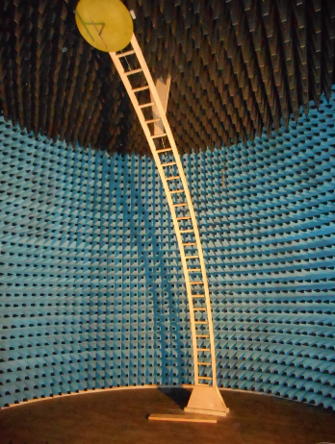
Figure 1: Anechoic chamber interior view

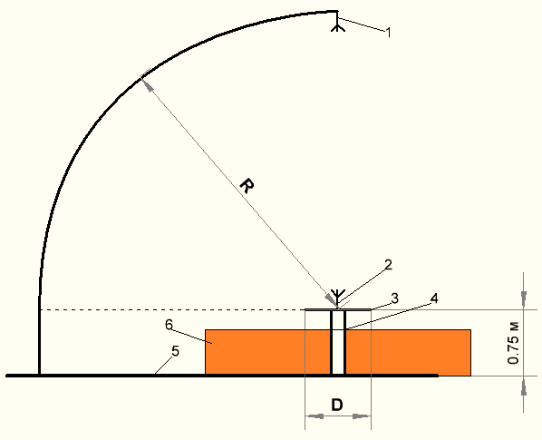
Figure 2: Open-air antenna test setup

Legend
1 measuring antenna
2 antenna under test
3 conductive ground plane (GPB)
4 turntable base
5 conductive floor ground plane (GPA);
6 RAM

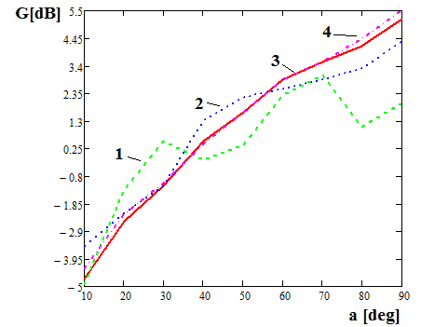
Figure 3: Micro-strip (patch) measured and simulated antenna patterns

Legend
1 measured with ground plane B diameter D=2.5m
2 measured with ground plane B diameter D=2m
3 measured with ground plane B diameter D=0.5m
4 simulated antenna pattern

Table 1 - Navigation system requirements in documents C/S T.007 and C/S T.021
C/S T.007 Section/Annex | C/S T.007  Section title | C/S T.018 section | C/S T.021 Section | Notes
6.4 | Internal Navigation Device | 4.5.5.4 | 6.5.5.4 | See Attachment 1
6.4.1 | Inclusion or removal of Internal Device |  | B.3.1
6.4.2 | Change to Internal Navigation Device |  | B.3.2

RECOMMENDATIONS
[examples of typical recommendations provided below]

[participant] recommends that the Joint Committee

[invite participants to prepare, review, amend, further analyse...]

[review and amend as appropriate proposed amendments to document C/S X.00X, and recommend its approval at CSC-xx]

[recommend that interested participants, such as those collaborating within the Correspondence Working Group on [subject], continue/review/develop, etc. and present proposals/amendments at [meeting]]

[Based upon the results of the xxMCC Commissioning, the xxMCC, acting as host MCC, recommends that the Joint Committee commission the new xxMCC as a Cospas-Sarsat MCC operating at IOC status since [date]]

[invite participants to continue investigation into [subject] and report the progress to CSC-xx and future Cospas-Sarsat meetings]

[invite the Secretariat to prepare, review, amend]

NOTES:

All bulky documents over 10 pages must be submitted to the Secretariat 6 weeks prior to the meeting start date. All other documents must be submitted 4 weeks prior to the meeting start date.

Revision papers and corrigenda should highlight the changes to the originally submitted document using italicized insertions and deletions shown in strikethrough.

Headers: For attachments, insert a Next Page section break after the end of the paper. The path in MS Word 2010 or 2013 is Page Layout/Breaks/Section Breaks/Next Page.

Attachment headers should be as follows: JC-30/x/x - Attachment 1.

Revision headers should be as follows: JC-30/x/x - Rev.x.

When modifying the header design, make sure the option “link to previous” is NOT selected.

[When the paper is completed, it should be uploaded for posting at http://www.cospas-sarsat.int/en/meetings-pro/submit-meeting-documents]

- END OF DOCUMENT -

