Letter Template to Communicate SIT 185 Message Changes
to SPOCs, RCCs and Distress Authorities

INTRODUCTION

As an associated Search and Rescue Point of Contact (SPOC) or Rescue Coordination Centre (RCC) supported by the [MCC name], you receive alert notifications for active 406 MHz distress beacons within your search and rescue (SAR) area of responsibility from the International Cospas-Sarsat Programme. These alerts come to you as Distress Alert Messages in the form of “subject indicator type” SIT 185 messages. The content and organization of these messages is changing, and the purpose of this letter is to bring your attention to these changes and to provide further detail.

Distress and SAR Authorities should note that coordination may be needed between MCCs (including backup MCCs) and supported SPOCs and RCCs to ensure that:

- any customized procedures or documents used by SPOCs and RCCs to interpret the SIT 185 message are properly updated; and

- any software deployed by SPOCs and RCCs to parse/manage SIT 185 messages is appropriately updated to process the new SIT 185 message format and content.

BACKGROUND

The SIT 185 message content is provided in a text format suitable for human and machine reading. This facilitates both manual and automatic processing. The format of these messages, sent to SPOCs and RCCs, has remained largely unchanged for many years. Additions, enhancements, and improvements to the Cospas-Sarsat System, including the new MEOSAR satellite system, mean that new information has been added, such as “DOA position” data (“difference of arrival” position calculated by the receiving MEOLUT based on differences in time or frequency in the received distress signal; as distinguished from “GNSS position”). To avoid possible confusion or inefficiencies in the way beacon location information is provided, and help to ensure proper interpretation by SPOCs, RCCs, and SAR responders, a review of the SIT 185 message format was undertaken.

After two years of work by the international Cospas-Sarsat community, changes to the SIT 185 message format have been agreed. The Cospas-Sarsat System documents have been amended to specify this new format, but additional time will be required to implement this change in all MCCs. Therefore, for a period of time, you might receive SIT 185 messages in either the old or new format.

THE NEW SIT 185 MESSAGE FORMAT

The SIT 185 message format is specified in Cospas-Sarsat document C/S A.002 as the “Message used for alert and NOCR (Notification of Country of Beacon Registration) messages from MCCs to SPOCs”. The SIT 185 format provides information about an active beacon, e.g., date, time, beacon ID, satellite system providing the information, and position estimate.

An MCC, when serving as the backup to another MCC, may directly support (communicate with) the RCCs and/or SPOCs of the non-operational MCC, or may route message traffic through a SAR authority nominated by the non-operational MCC to help manage traffic to the RCCs and/or SPOCs. It should be noted that an MCC may choose to support its SPOCs and RCCs with a national message format and communication procedure, as an alternative to the SIT 185 message.

New (subsequent) SIT 185 messages are sent to SPOCs and RCCs from their supporting MCC when location information is updated.

The new presentation of the information provided in a SIT 185 format is shown in Attachment A.
The improvements made to reduce confusion and improve clarity include, in particular:
- Use of the term “GNSS position” to replace “Encoded position”,
- Use of the term “MCC Reference position” instead of “Confirmed position”,
- Reorganizing the content of the SIT 185 message.

Although the terms for some position data are changing, the significance of the data provided is unchanged. As a reminder, the position data can be summarized as follows:

- The "GNSS position" provides the location transmitted in the beacon message from a local source if one is available (which may be a GPS/Galileo/Glonass Global Navigation Satellite System receiver built into the beacon, or an external navigation device to which the beacon is connected); depending on the beacon-message protocol used, this position accuracy often is better than 60 meters or, in rare circumstances, as great as 28 km,
- The "MCC Reference position" is an estimated position selected by an MCC algorithm based on a match of positions calculated by two independent sources to be within 20 km of each other,
- The "DOA position" provides a location calculated by a MEOLUT from the received beacon signal and typically is accurate within 5 km,
- The "Doppler A" and "Doppler B" positions are calculated by a LEOLUT from the received beacon signal, each having a probability (shown in the SIT 185 message) of being the correct location, typically within 5 km (unless the word “SUSPECT” and further advice is provided in paragraph/box 5 of the message); the “GNSS”, “MCC Reference” or “DOA” positions may help to resolve ambiguity between "Doppler A" and "Doppler B" positions.

The above explanations are simplified summaries only. For further information, please see Attachment B, and for complete information, please see sections 2.7 and 5.4.7 of document C/S G.007 (“Handbook on Distress Alert Messages for Rescue Coordination Centres (RCCs), Search and Rescue Points of Contact (SPOCs) and IMO Ship Security Competent Authorities”), http://cospas-sarsat.int/en/documents-pro/system-documents.

As decided by the Cospas-Sarsat Council, MCCs are expected to implement the new SIT 185 message format by March 2023. As your supporting MCC, the [xxMCC] is planning to implement this change in [month and year]. Note that the [xxMCC] has a backup MCC (the [zzMCC]), which is planning to implement the new SIT 185 message format in [month and year]. Therefore, SPOCs and RCCs may receive SIT 185 messages in either the new or old formats until both the supporting MCC and backup supporting MCC have implemented the new format. This possible staggered implementation should be taken into account, if a SPOC or RCC deploys software to parse/manage SIT 185 messages.

More detailed information on SIT 185 message content can be obtained by contacting your supporting MCC, or by reviewing documents C/S A.002 (“Cospas-Sarsat Mission Control Centres Standard Interface Description (SID)”) and C/S G.007 on the Cospas-Sarsat web site (http://cospas-sarsat.int/en/documents-pro/system-documents).

ATTACHMENT A
Sample New SIT 185 Format
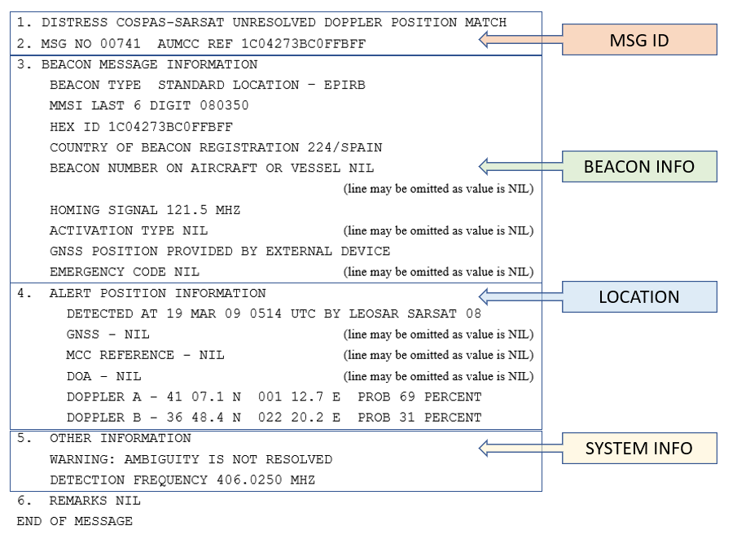

There may be multiple locations shown in paragraph/box 4. As available, the most recent location data is provided for each new SIT 185 alert message (in the “DOA”, “GNSS” and “Doppler” fields), as well as the current “MCC reference” position. More detailed guidance about position data contained in the SIT185 message is available in section 5.4.7 of document C/S G.007, http://cospas-sarsat.int/en/documents-pro/system-documents.
ATTACHMENT B

SIT 185 Position Information Reference Table*
Type of position | Description | Source of position | Position uncertainty | Notes
GNSS | Global Navigation Satellite System –such as GALILEO, GPS, GLONASS, etc. The GNSS position is transmitted by the beacon and determined by a navigation source in, or connected to, the beacon. | Position is provided by a navigation system within the beacon or external to the beacon.  Section 3 of the SIT185 message might provide information on the source of the device used to provide the position. | Will vary depending on the source and message format used; position precision is usually 60 meters but in rare circumstances, can be as great as 28 km. You will find the information in section 5 “Other information” of the SIT185 message. | Replaces the term “encoded position”. There may be a transition period when either term is used as MCCs update their systems.  Note: external source could include a position supply by an older type of navigation instrument on the aircraft.
MCC Reference position | An approximation of the beacon position estimated or selected by the MCC. It may be further updated based on new position data. | Determined by an MCC, based on a match of positions from independent sources within 20 kilometres of one another. | Within 20 km of one another. | Replaces the term “Confirmed position”. There may be a transition period when either term is used as MCCs update their systems.
DOA | A DOA (Difference of Arrival) position is a combination of time difference of arrival (TDOA) and frequency difference of arrival (FDOA) computations. | A DOA position is computed by a MEOLUT (Minimum 3 independent detections of beacon transmission). | Relates to the calculated estimated horizontal error (EHE). Information provided in Section 4 “Alert position information” of the SIT185 message.
Doppler | Based on signals received from a LEOSAR satellite. A single LEOSAR pass will generate an “A” position and “B” position. The “A” and “B” position can be resolved with further satellite detections. | A Doppler position is computed by a LEOLUT. LEOSAR satellites re-broadcast received beacon transmissions immediately (SARR) and/or from stored data (SARP). | The Doppler position should be accurate within five (5) kilometres 95% of the time. Further information to be provided in the section 5 “Other information” of the SIT 185 message. | A probability is provided, in the SIT 185 for both Doppler positions (“A” and “B”), indicating the likelihood they correspond to the real beacon position.

*More detailed guidance about position data contained in the SIT 185 message is available in section 5.4.7 of document C/S G.007, http://cospas-sarsat.int/en/documents-pro/system-documents.

